EXPERIMENT 19 — TRIGGER
AIM
To implement trigger in MySQL.

Create employee table
DROP TABLE IF EXISTS employees;

CREATE TABLE employees (
id INT PRIMARY KEY,
name VARCHAR(50),
email VARCHAR(100)
);
Insert data
INSERT INTO employees VALUES
(1, 'G.Chakri', 'chakri@gmail.com'),
(2, 'Ravi', 'ravi@gmail.com'),
(3, 'Rani', 'rani@gmail.com');

Create audit table
DROP TABLE IF EXISTS employees_audit;

CREATE TABLE employees_audit (
id INT,
name VARCHAR(50),
email VARCHAR(100),
action_time TIMESTAMP DEFAULT CURRENT_TIMESTAMP
);

Create BEFORE UPDATE trigger
DROP TRIGGER IF EXISTS employee_before_update;

DELIMITER $$

CREATE TRIGGER employee_before_update
BEFORE UPDATE ON employees
FOR EACH ROW
BEGIN
INSERT INTO employees_audit (id, name, email)
VALUES (OLD.id, OLD.name, OLD.email);
END $$

DELIMITER ;

Update an employee
UPDATE employees
SET name = 'G.Chakri Updated'
WHERE id = 1;

Check employee table
SELECT * FROM employees;
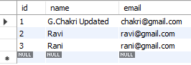

Check audit table
SELECT * FROM employees_audit;
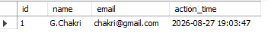

RESULT
Thus the trigger was implemented successfully in MySQL

